# Assemble the Robot Step by Step

--on Production

(The Four-wheel car)

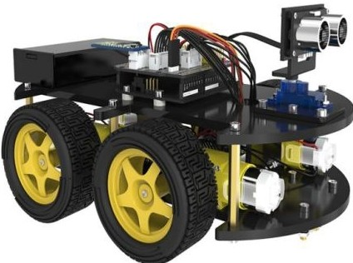

# Preface

**Our Company**

KUONGSHUN Electronic Company is a supplier and manufacturer of electronic components, it is committed to board and starter kit for Arduino, Raspberry PI, Smart Robot Car, 3D printer. It is also a collection of scientific research, design, production, maintenance and sales of high-tech enterprises, in the field of automation with professional standards and mature technology, we rapid rise in the field of foreign trade.

Relying on technology and development, continuing to provide users with high-tech products, is our constant pursuit. Fully introduction of foreign advanced technology to enhance the value of our products.

Company gains users' praise for supplying first-class quality product and superb technical services, has now become the first choice of domestic and international procurement company.

Our official website is: Http://www.kuongshun.com

**Our Tutorial**

This course and learning kit is designed for 8+ children and teenagers to Arduino-compatible boards, shields, sensors, and components. If you just start making with Arduino, this kit could provide the knowledge and components to create innovative projects.

**Customer Service**

As a continuous and fast growing technology company we keep striving our best to offer you excellent products and quality service as to meet your expectation and you can reach out to us by simply drop a line at info@kuongshun.cn We look forward to hearing from you and any of your critical comment or suggestion would be much valuable to us.

And any of problems and questions you have with our products will be promptly replied by our experienced engineers within 12 hours (24hrs during holiday)

we pursue the policy of "progressive, Truth, Rigorous and Unity", keeping innovation, paying attention of technology as the core, committing to quality and putting customer’s satisfaction on the priority, dedicated to provide you with the most cost-effective high-tech products and attentive service.

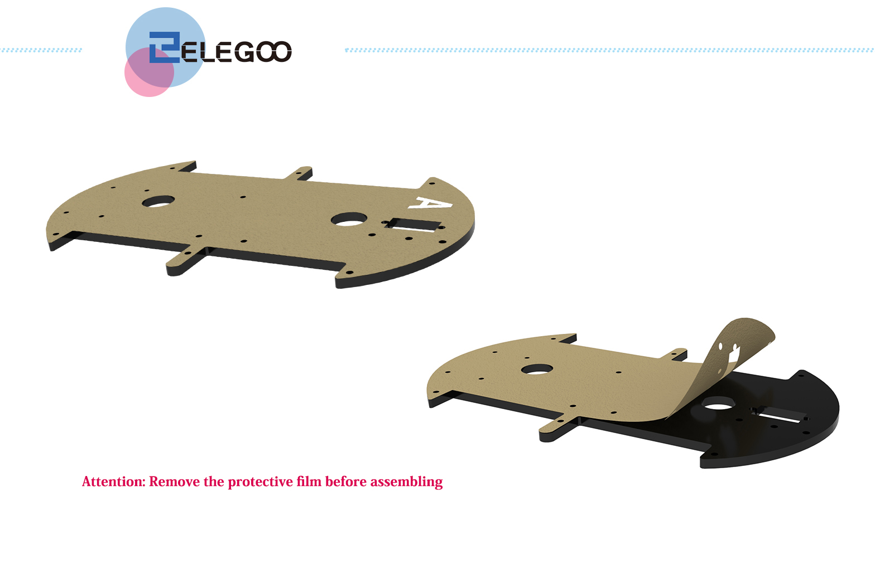

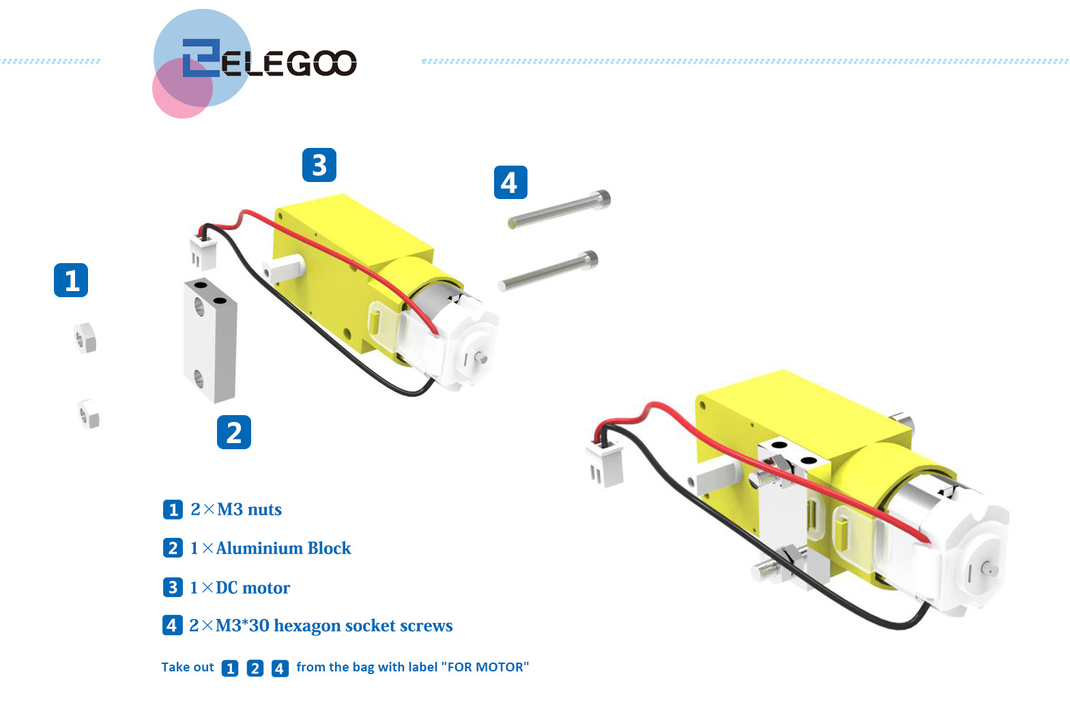

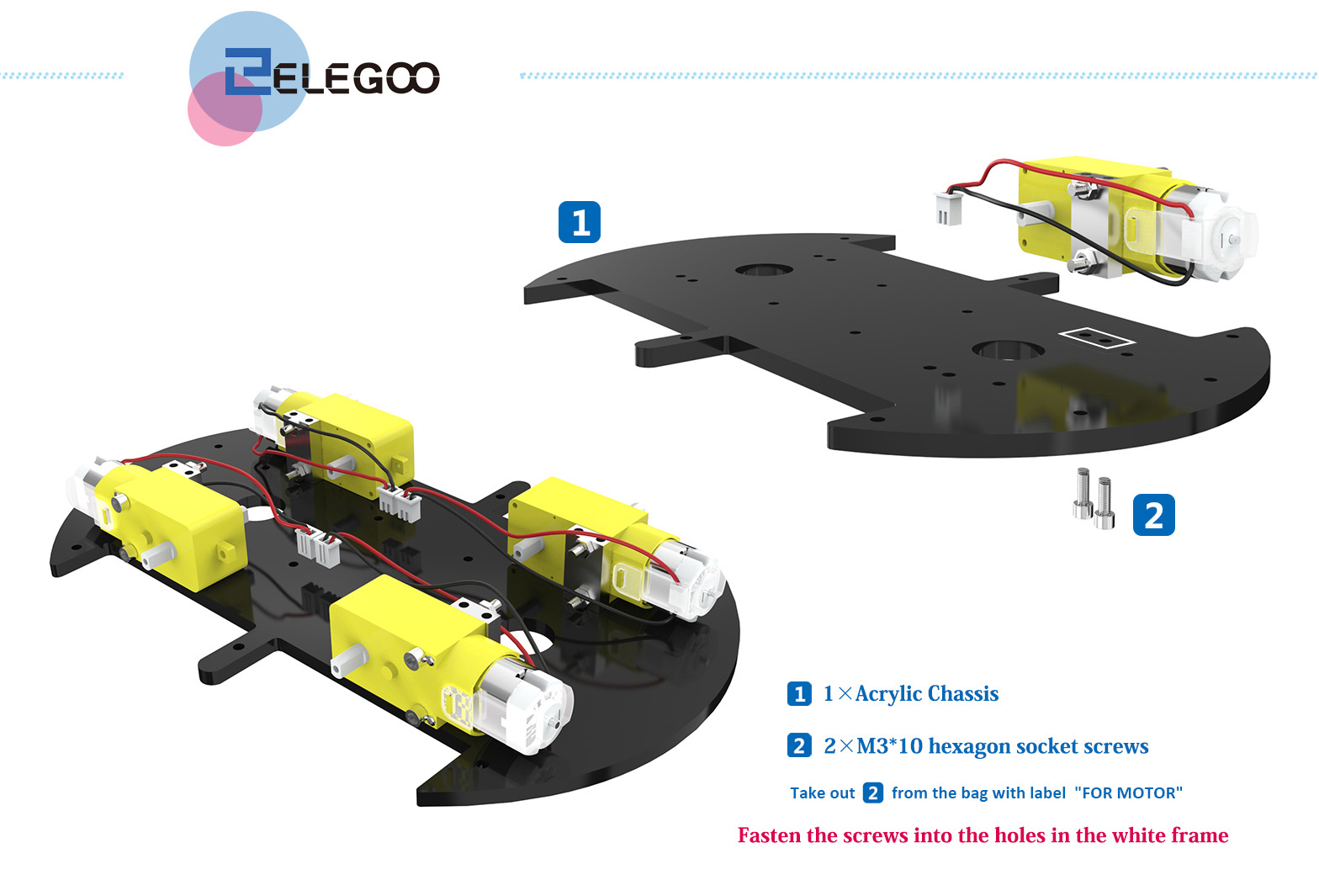

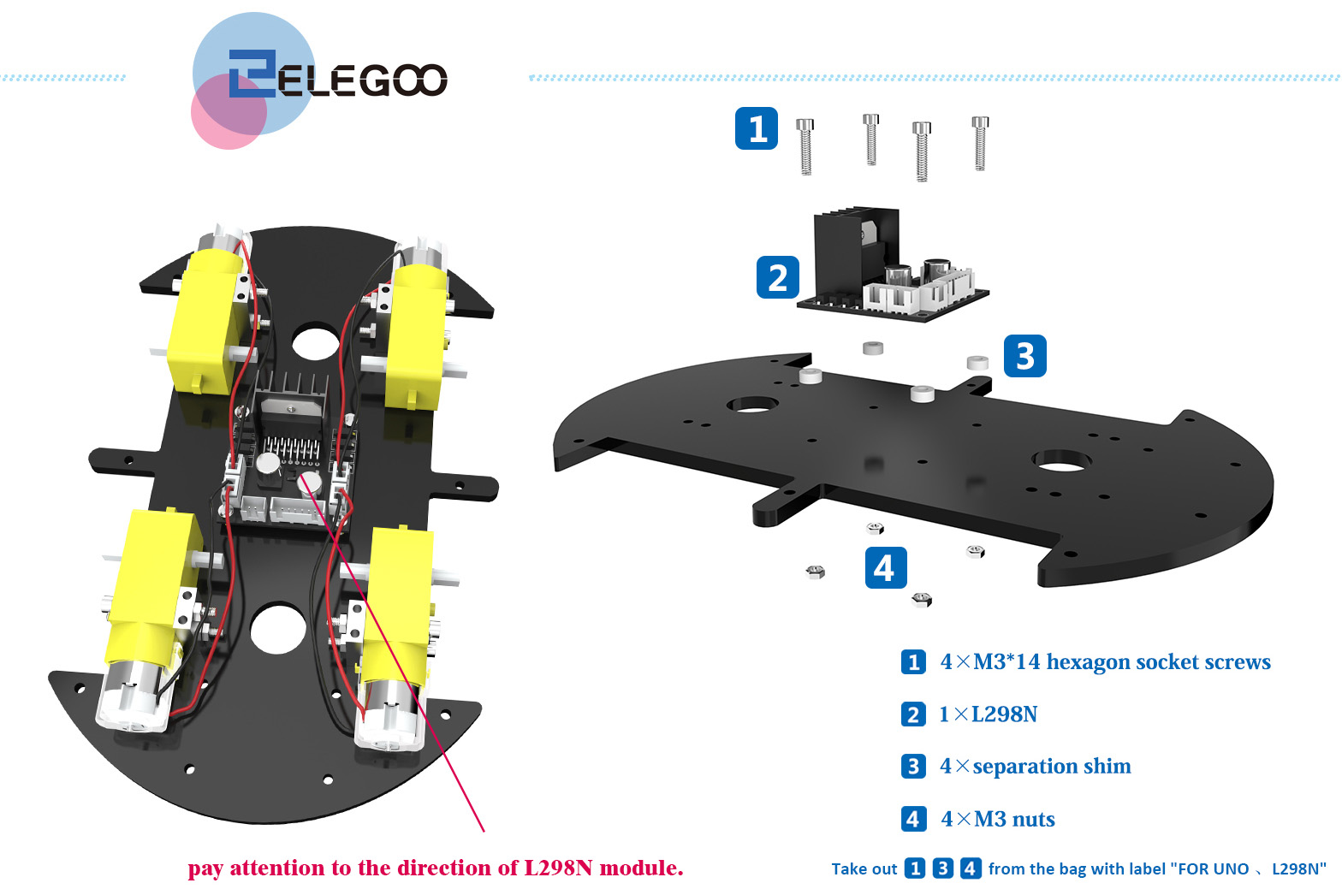

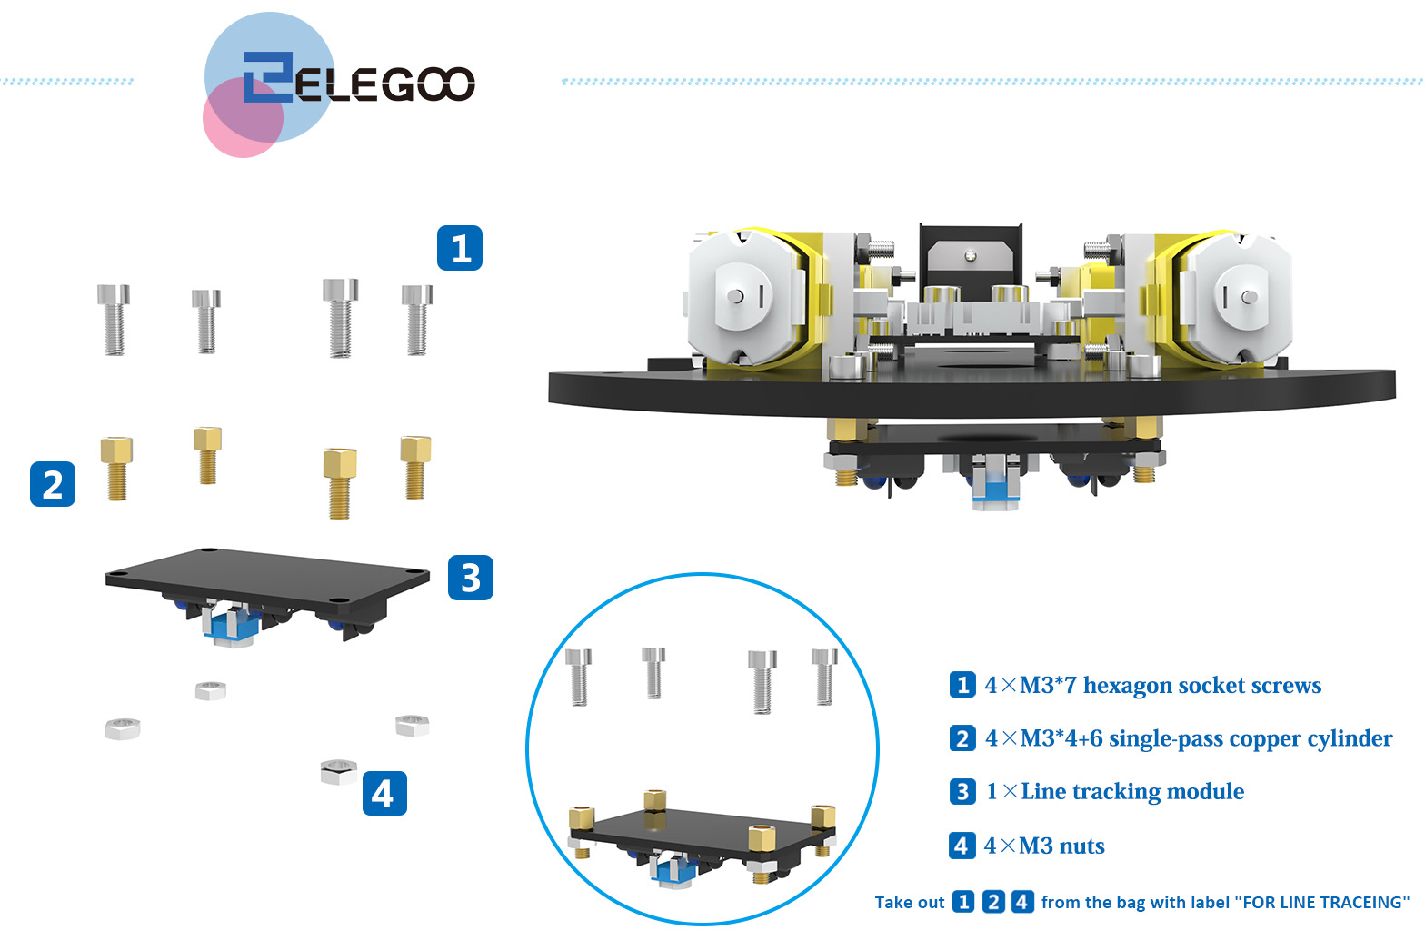

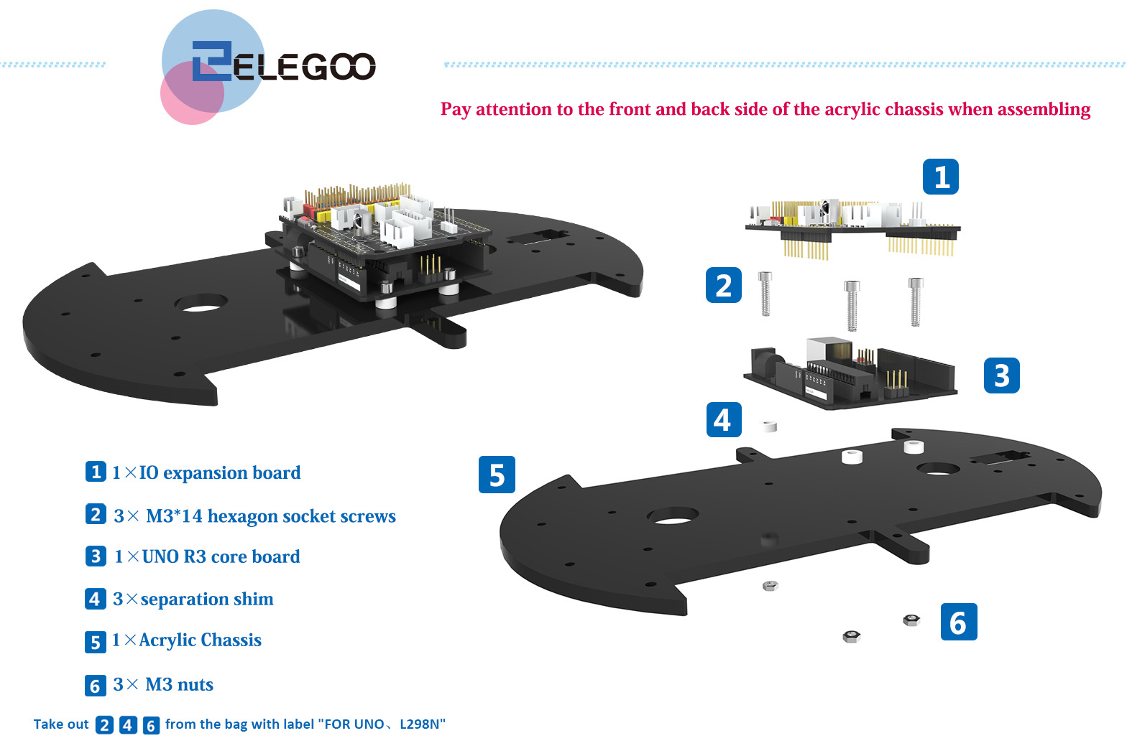

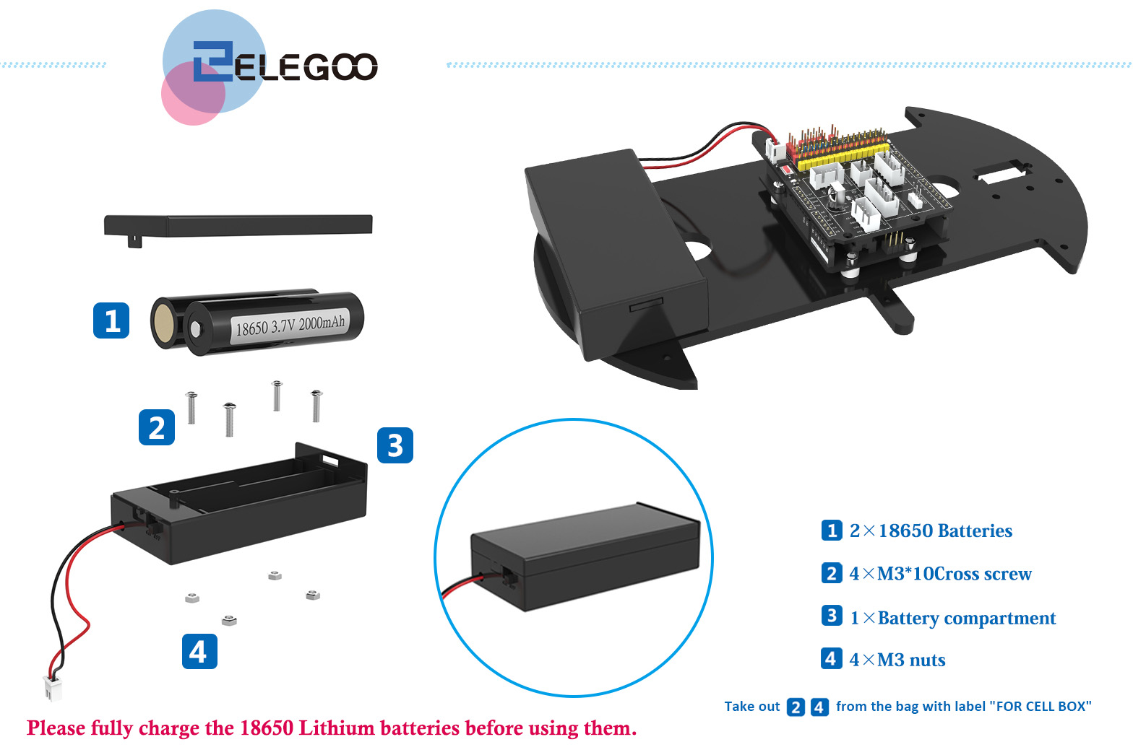

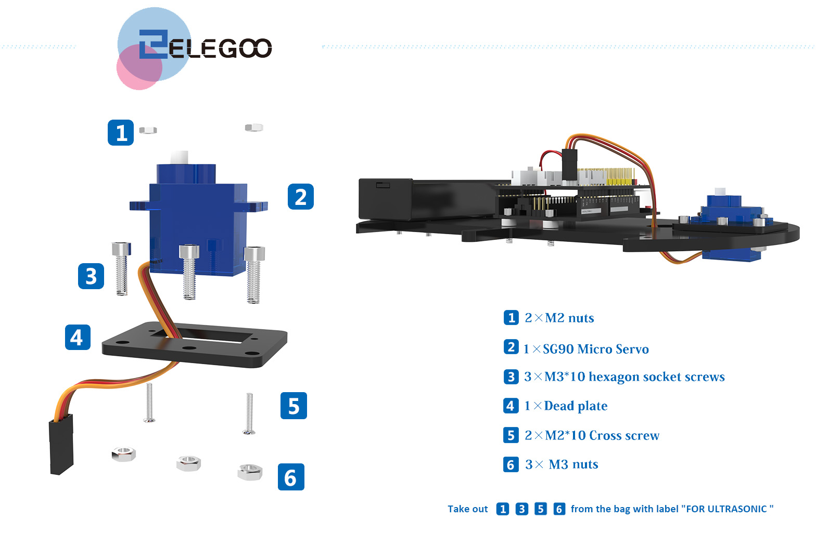

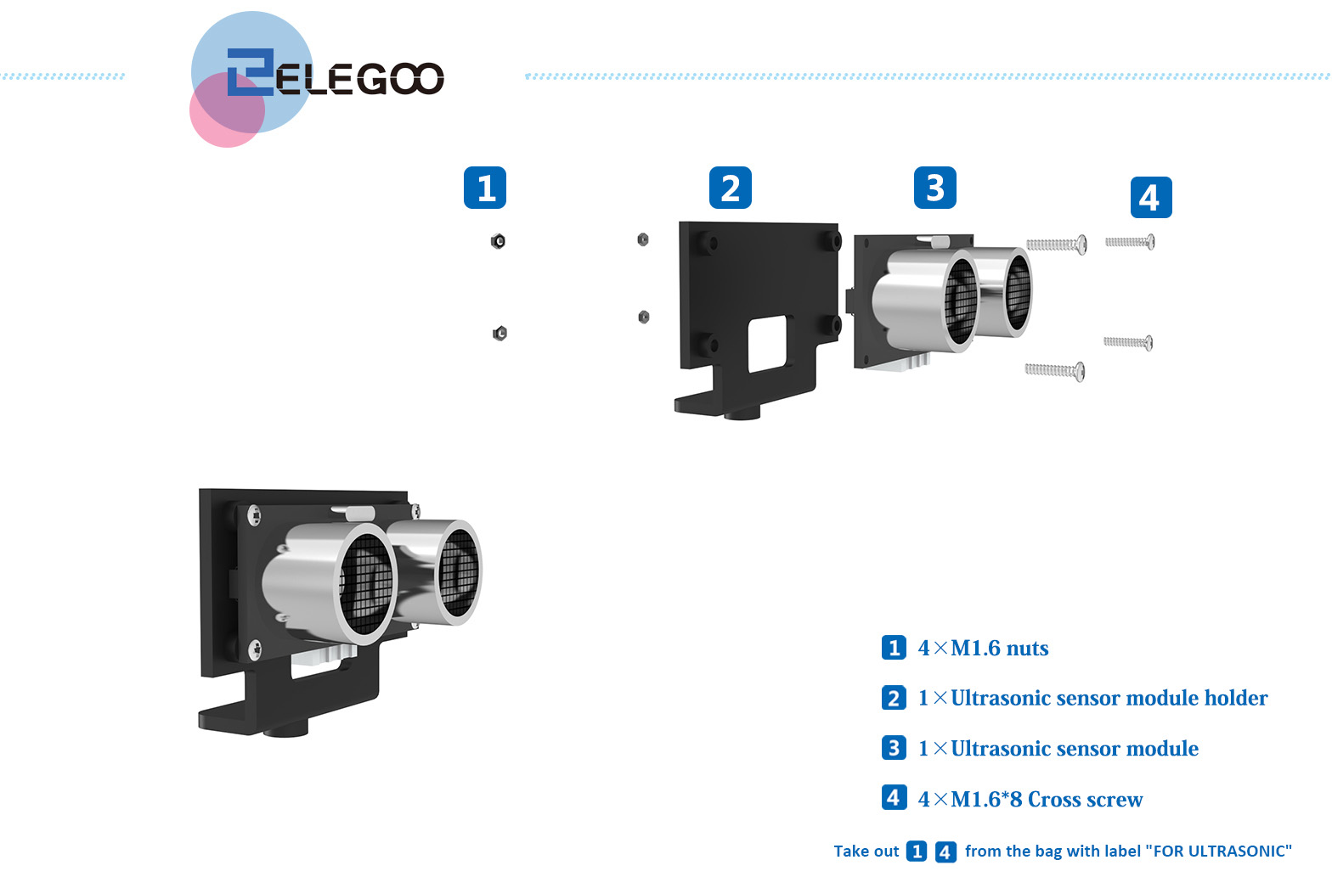

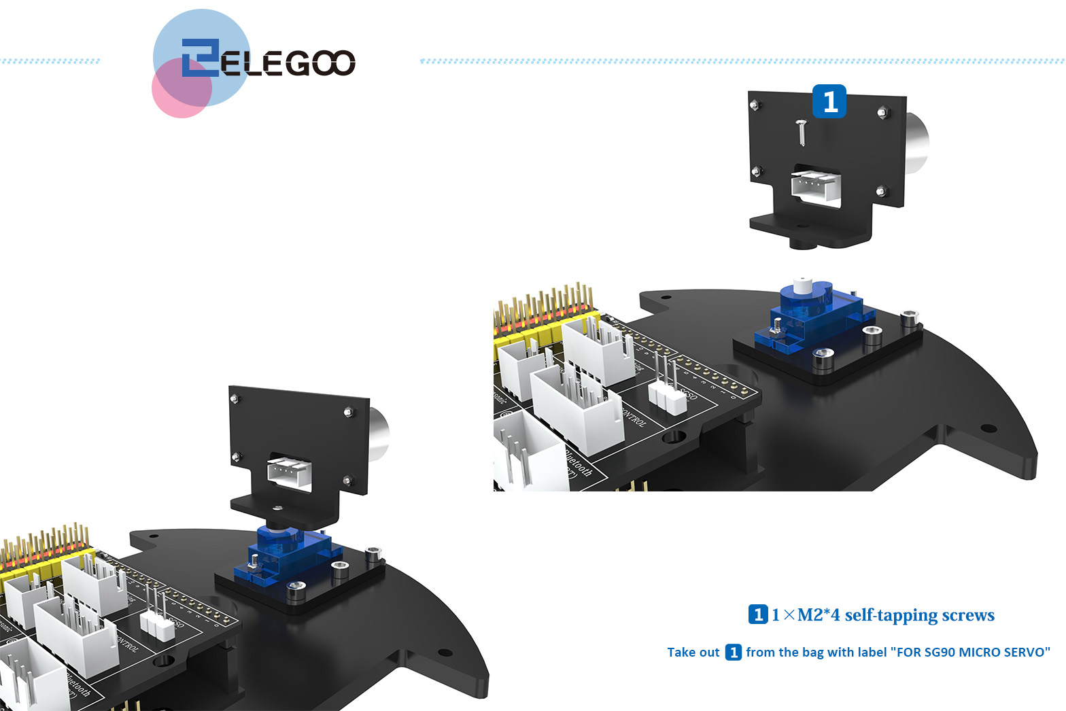

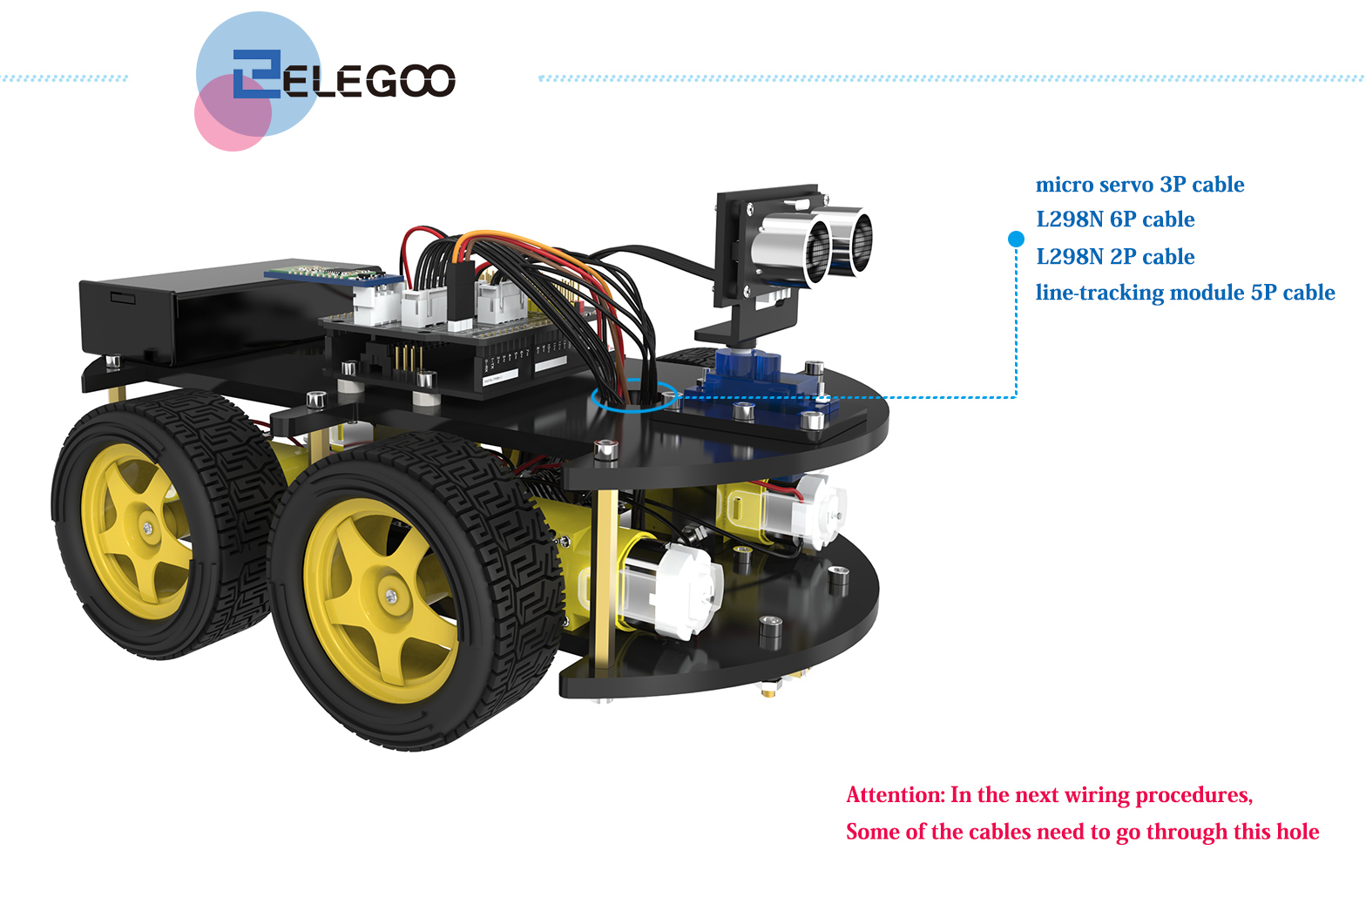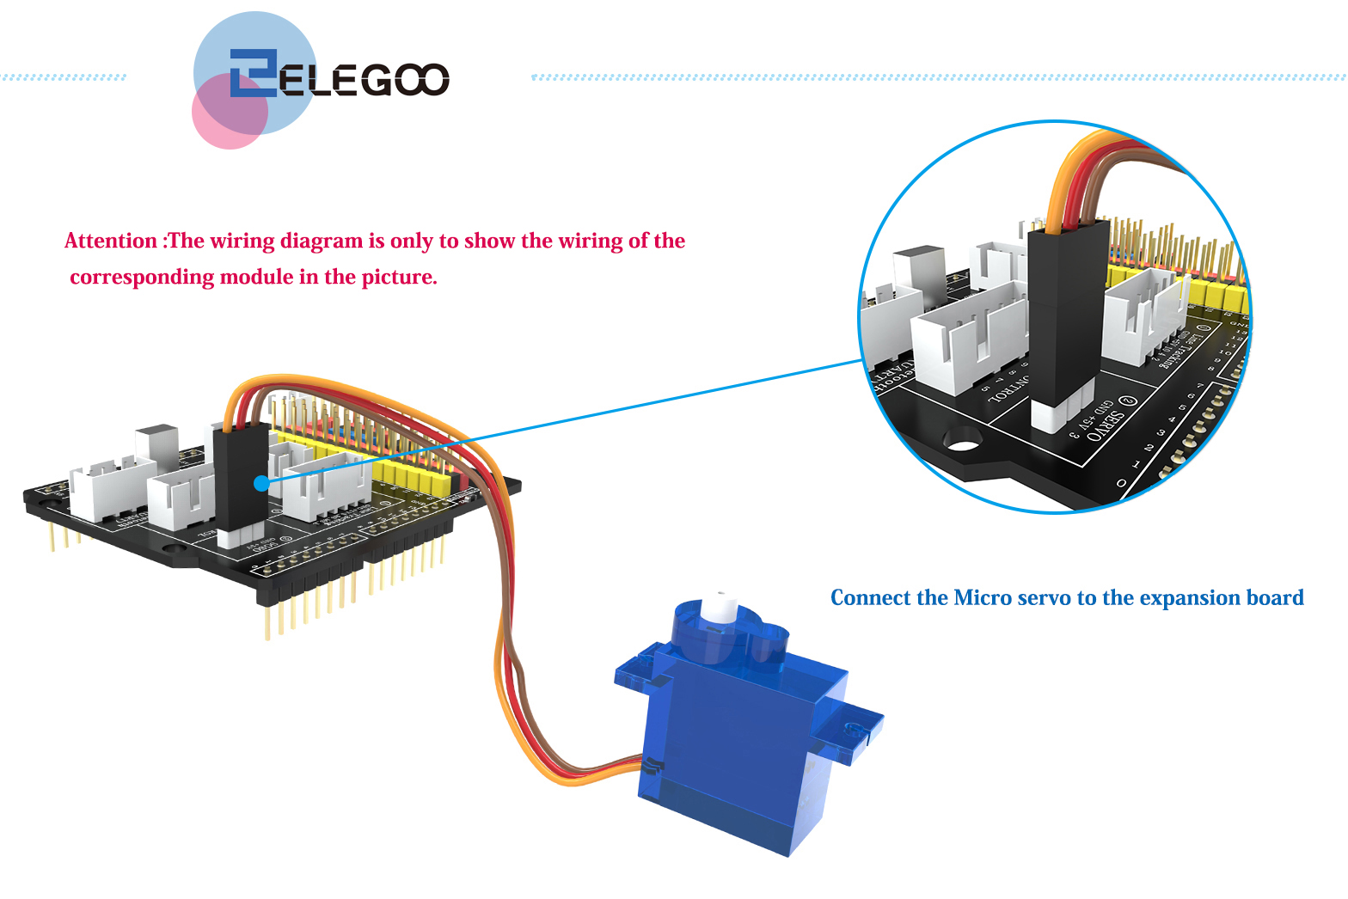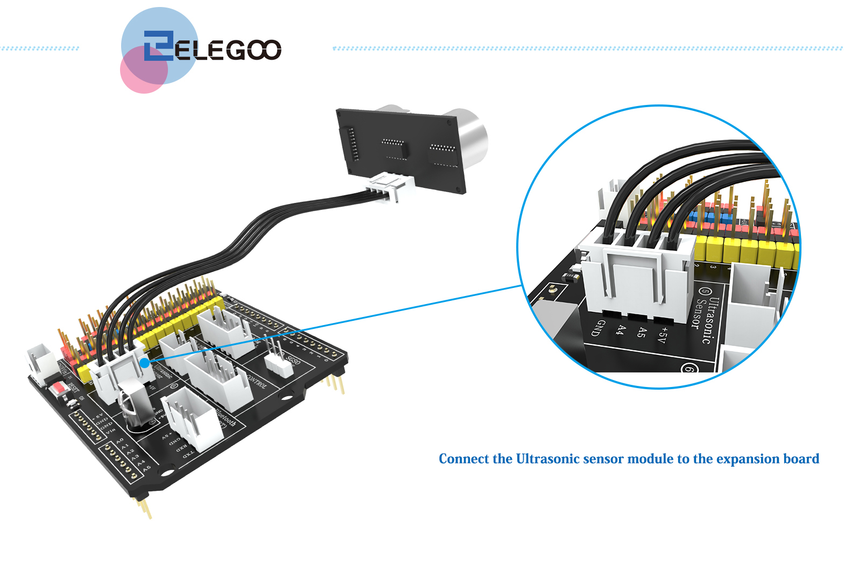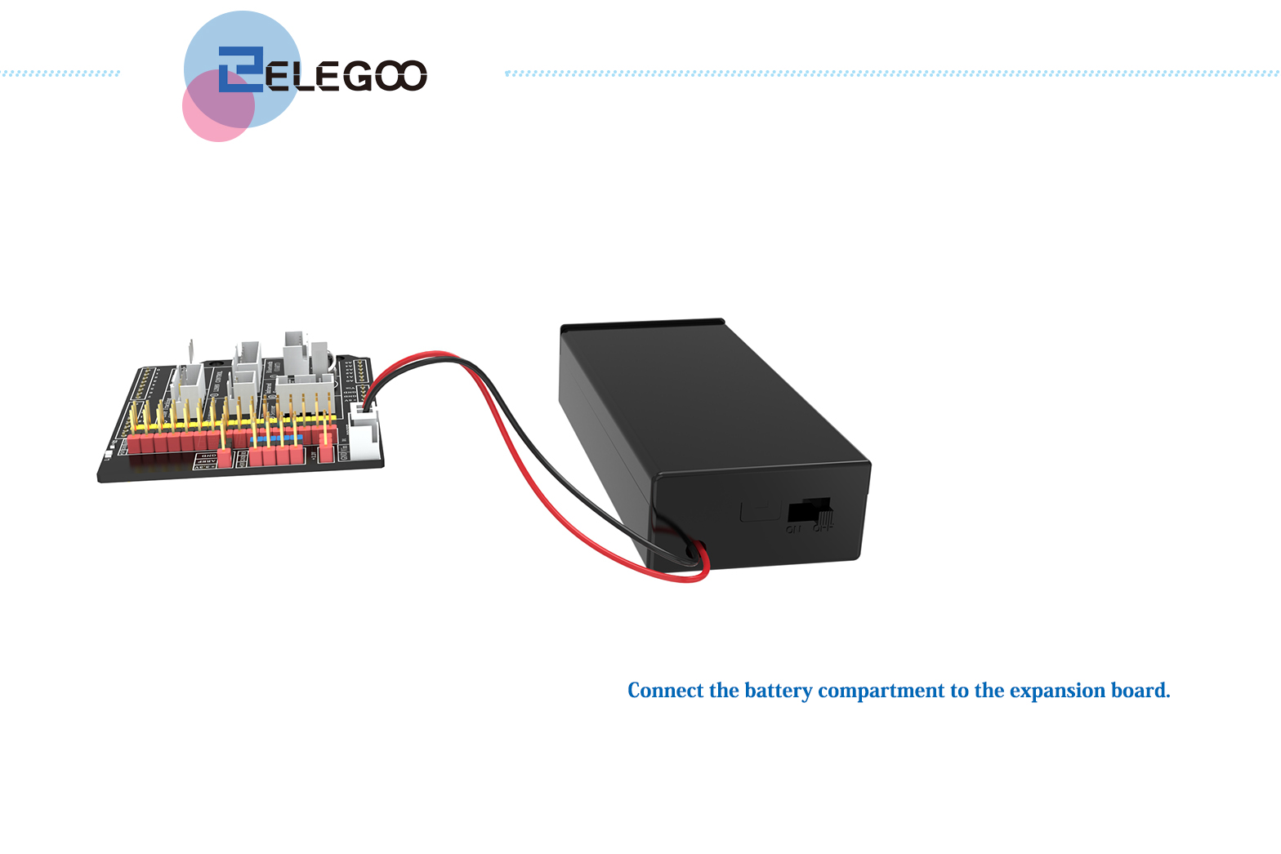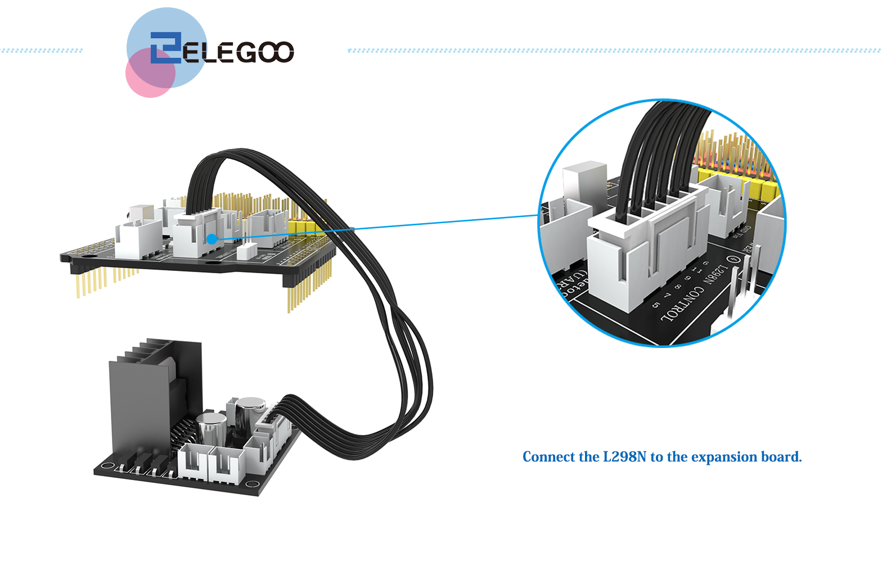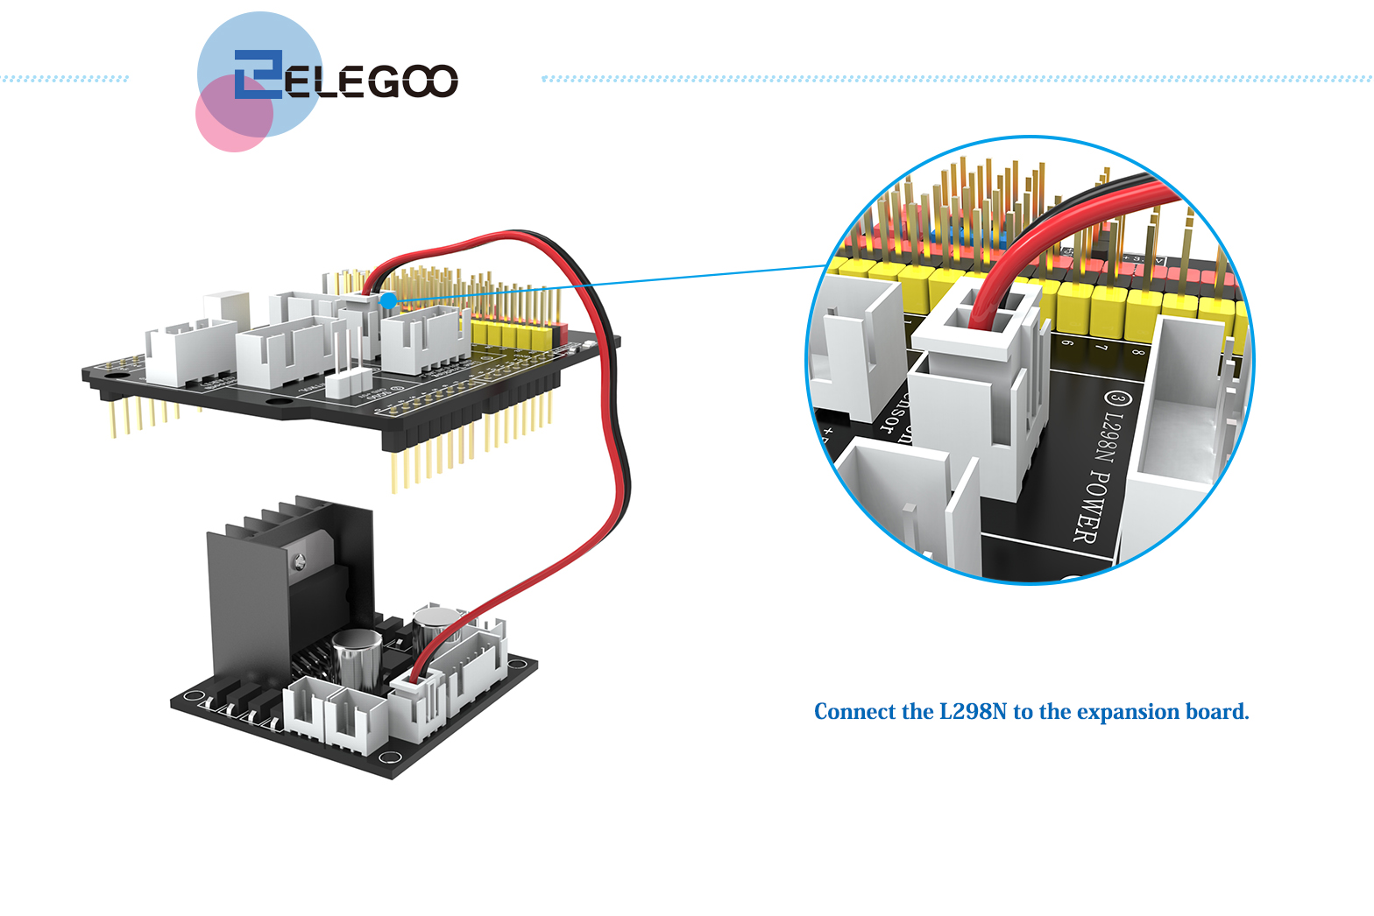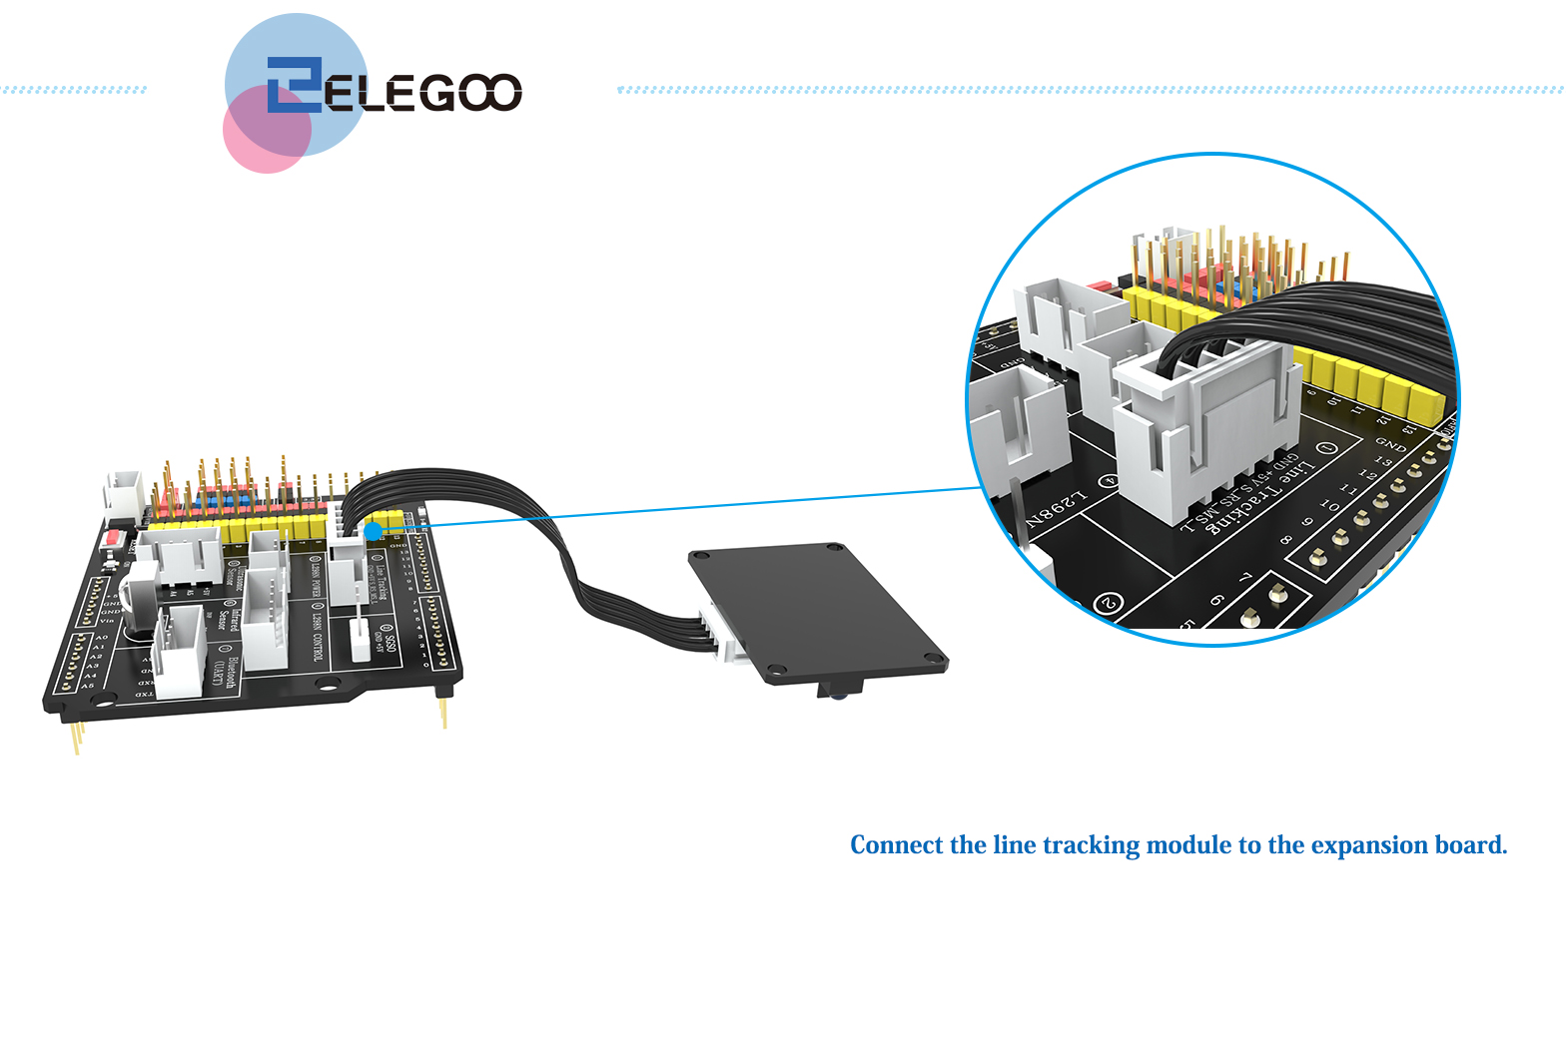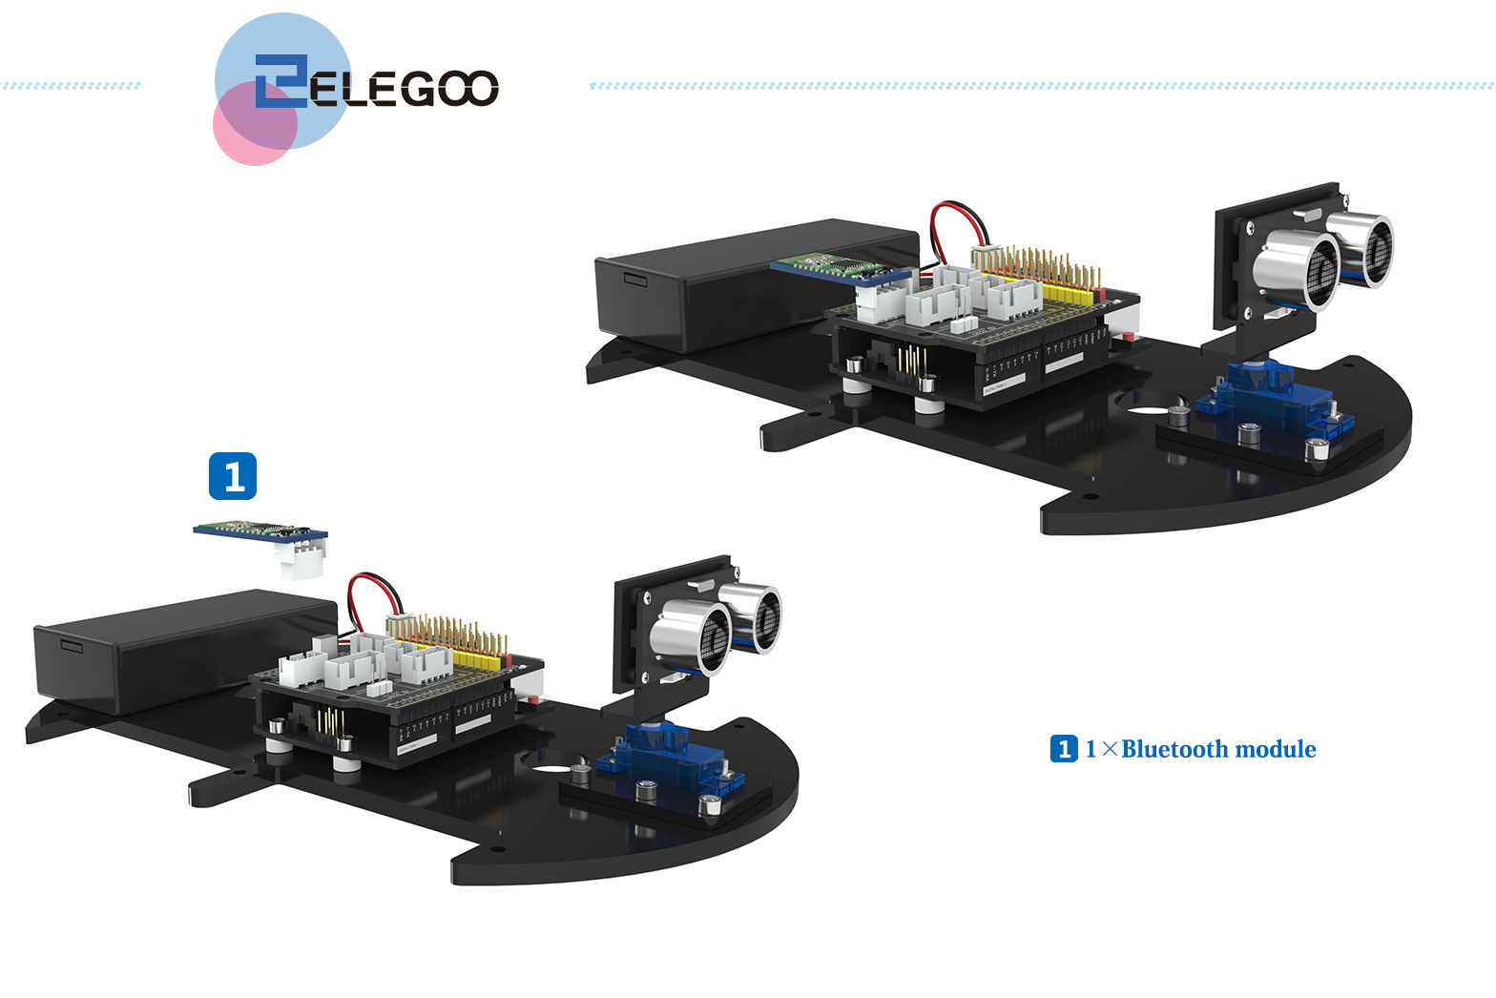

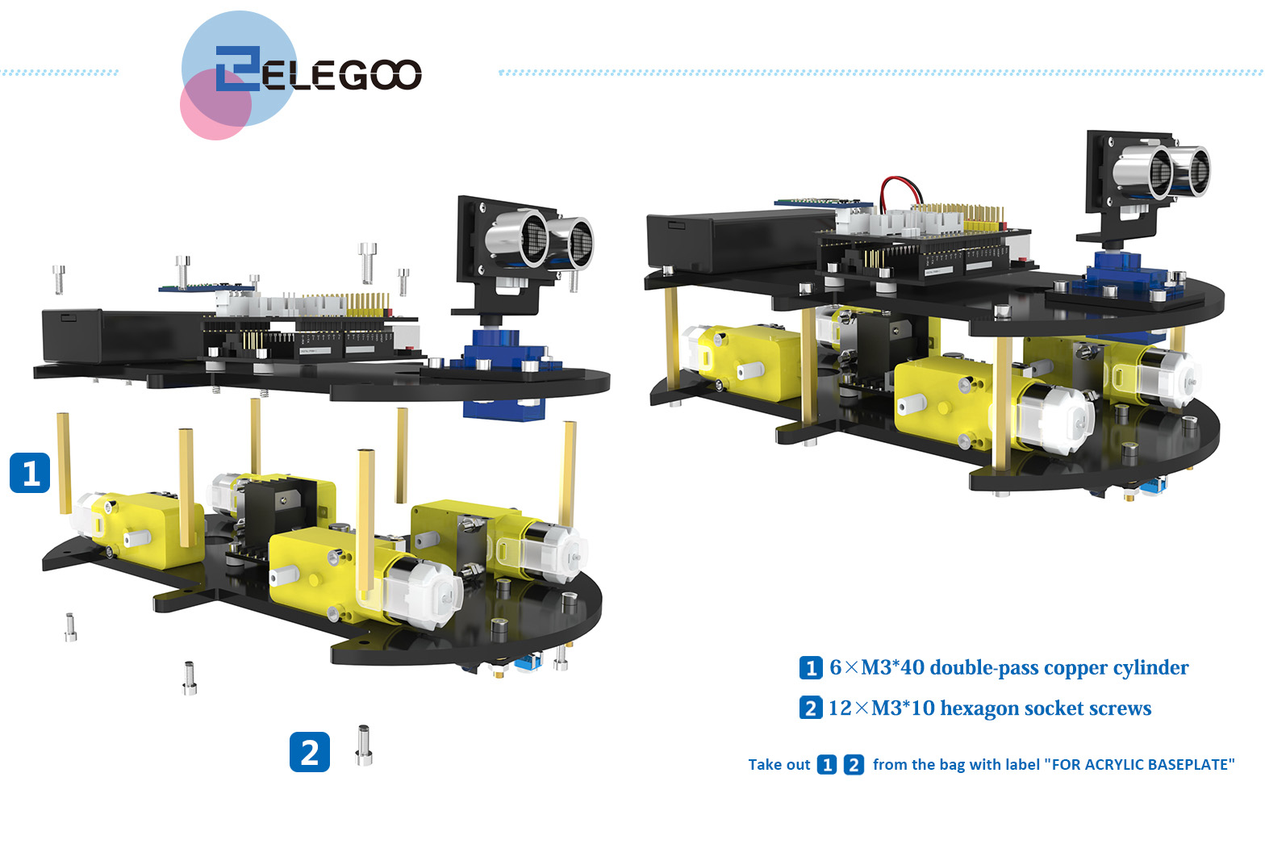

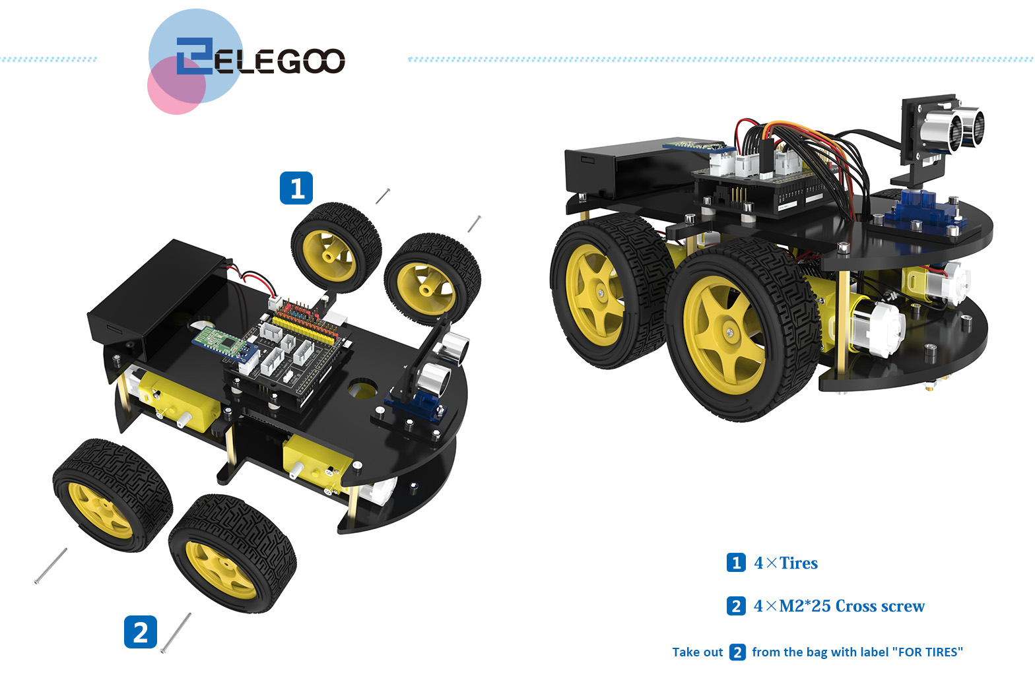

# Summary

This tutorial is aimed at making it easier to assemble the car and if you find any problems or have any suggestions for the tutorial or the robot car please feel free to send us an email at [info@kuongshun.cn](mailto:EUservice@elegoo.com)

After assembling and connecting all the components, we need to debug some basic programs of the car, which we will learn in the next lesson.